**1. Use ps to search for the “systemd” process by name.**

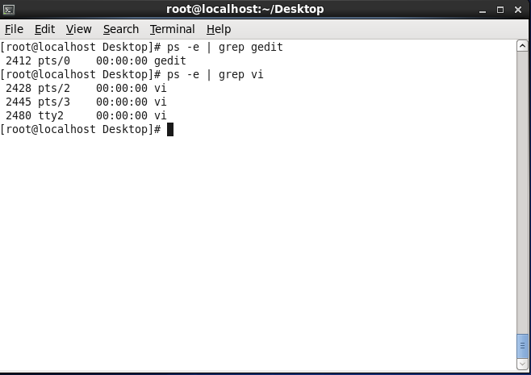

**2. Find out your terminal name.Using your terminal name, use ps to find all processes associated With your terminal.**

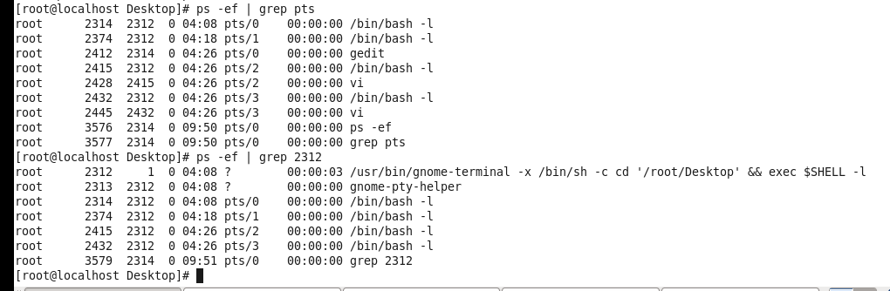

**3. Check and note the process id of your shell(from the output of the above command). Also, note the parent process id of your shell.**



**4. Start 3 instances of “sleep 123” as background processes.**

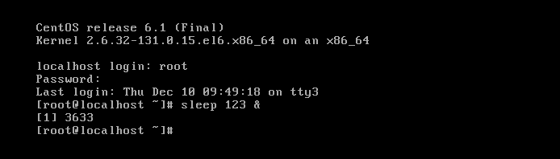

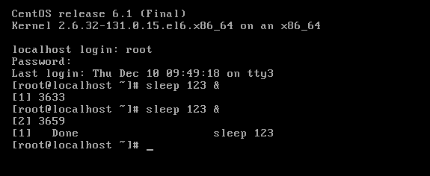

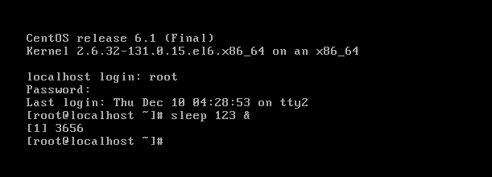

**5. Check and note the process id’s of all sleep processes.**

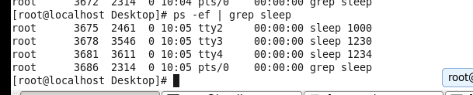

**6. Display only those three sleep processes in top. Then quit top.**

